|  |  |
| --- | --- |
| **Name:** | MANSI UNIYAL |
| **Roll Number:** | 19EE10039 |

**Experiment No. 2**

**Name of the Experiment:** VI Characteristics of a Diode

1. **Aim of the experiment**

Verify the forward and reverse biased V-I characteristics of a Silicon diode and Germanium diode, for different values of series resistance values.

1. **Tools used:**
   * + 1. V-labs
       2. Ammeter (in A)
       3. Voltmeter (in V)
       4. Connecting Wires
       5. Silicon diode
          1. 1N4001(VF =0.6V) (VR =30V)
          2. 1N4148 (VF =0.5V) (VR =20V)
       6. Germanium diode (VF =0.3V)
       7. DC Voltage source
          1. (varying from 0.2V to 30.2V)
          2. Reverse bias
       8. DC Voltage source
          1. (varying from 0.2V to 5V)
          2. Forward bias
       9. Resistances
          1. 100 ohms
          2. 200 ohms
2. **Background knowledge (brief):**

* Structure of P-N junction diode

The diode is formed from a junction of n-type and p-type semiconductor material. The lead connected to the p-type material is called the anode and the n-type material is the cathode.

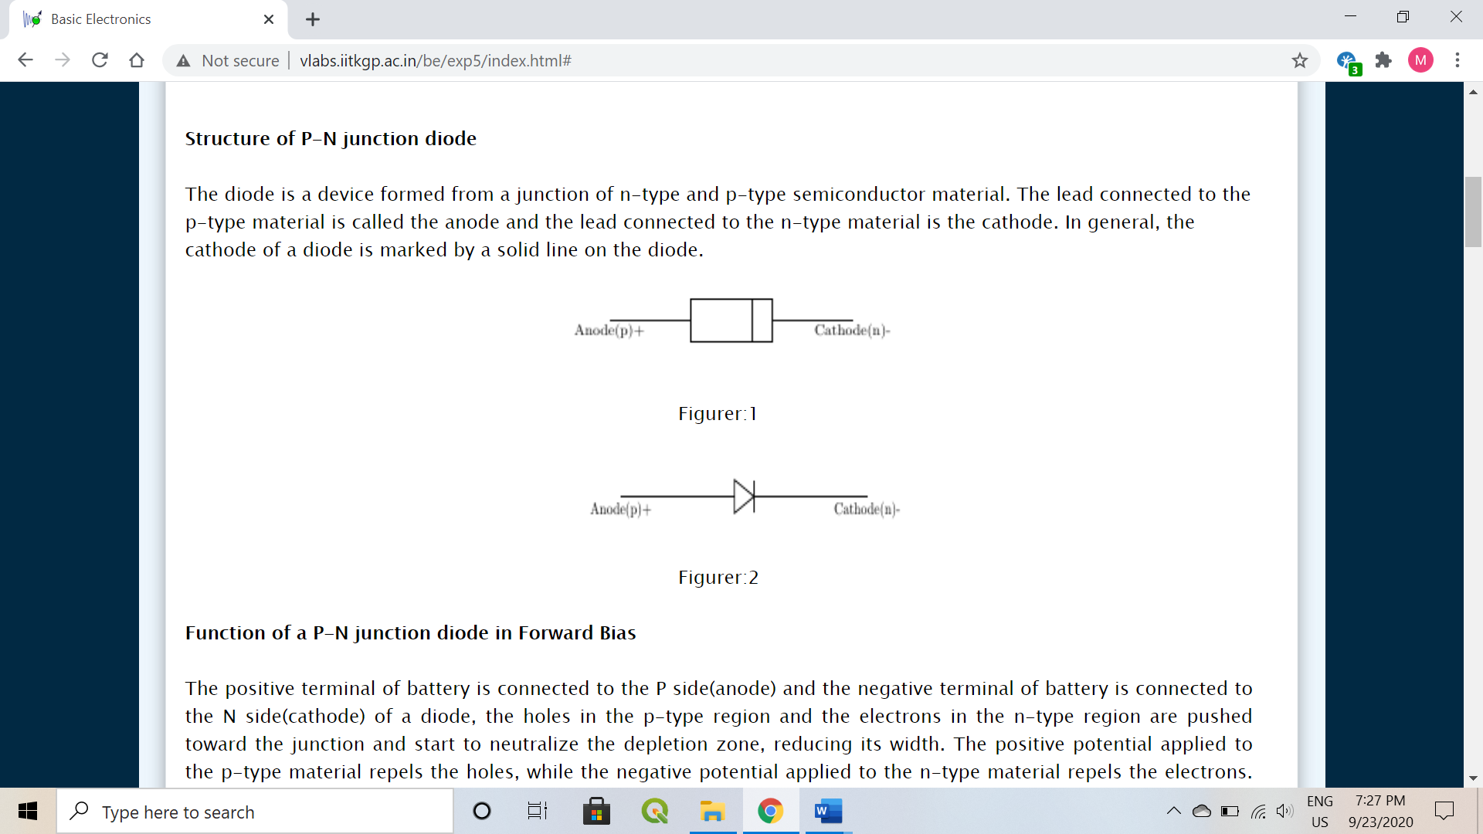

* Forward bias

The positive terminal of battery is connected to the P side and the negative to the N side of a diode, the holes in the p-type region and the electrons in the n-type region are pushed toward the junction and start to neutralize the depletion zone, reducing its width. The positive potential applied to the p-type material repels the holes, while the negative repels the electrons. The change in potential between the p side and the n side decreases or switches sign. With increasing forward-bias voltage, the depletion zone eventually becomes thin enough that the zone's electric field cannot counteract charge carrier motion across the p–n junction, which as a consequence reduces electrical resistance. The electrons that cross the p–n junction into the p-type material will diffuse into the nearby neutral region. The amount of minority diffusion in the near-neutral zones determines the amount of current that may flow through the diode.

* Reverse bias

The positive terminal of battery is connected to the N side and the negative to the P side of a diode. Therefore, very little current will flow until the diode breaks down. The 'holes' in the p-type material are pulled away from the junction, leaving behind charged ions and causing the width of the depletion region to increase. Likewise, because the n-type region is connected to the positive terminal, the electrons will also be pulled away from the junction, with similar effect. This increases the voltage barrier causing a high resistance to the flow of charge carriers, thus allowing minimal electric current to cross the p–n junction. The increase in resistance of the p–n junction results in the junction behaving as an insulator. The strength of the depletion zone electric field increases as the reverse-bias voltage increases. Once the electric field intensity increases beyond a critical level, the p–n junction depletion zone breaks down and current begins to flow.

1. **Circuit (hand drawn/image)**

* FORWARD BIAS

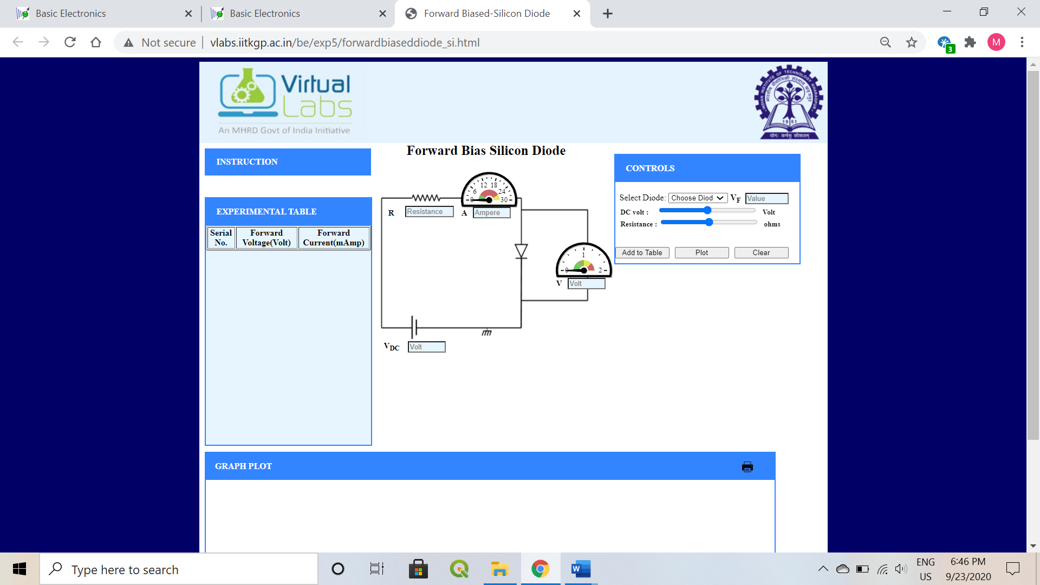

* REVERSE BIAS

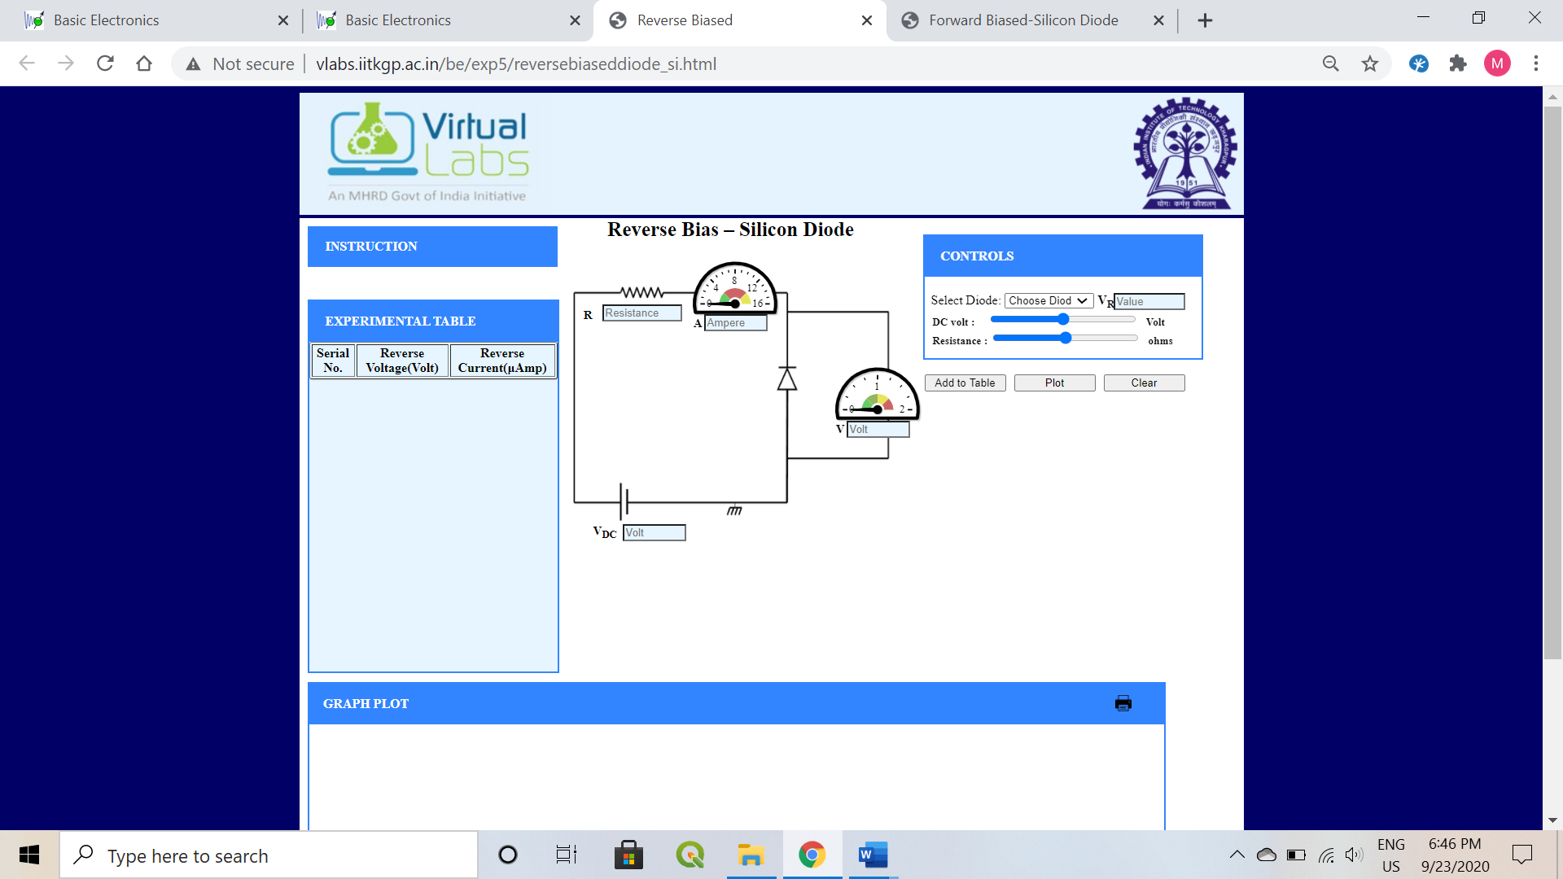

1. **Measurement Data (Tabular form)**

* Silicon Diode (1N4001)
  + Resistance (100 ohms)
    - Forward bias

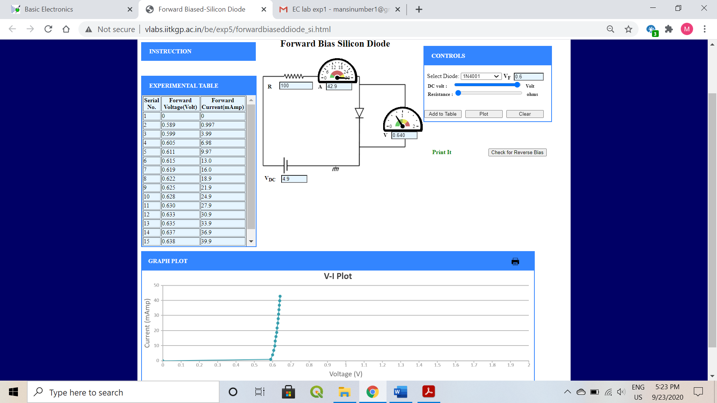

* + - Reverse bias

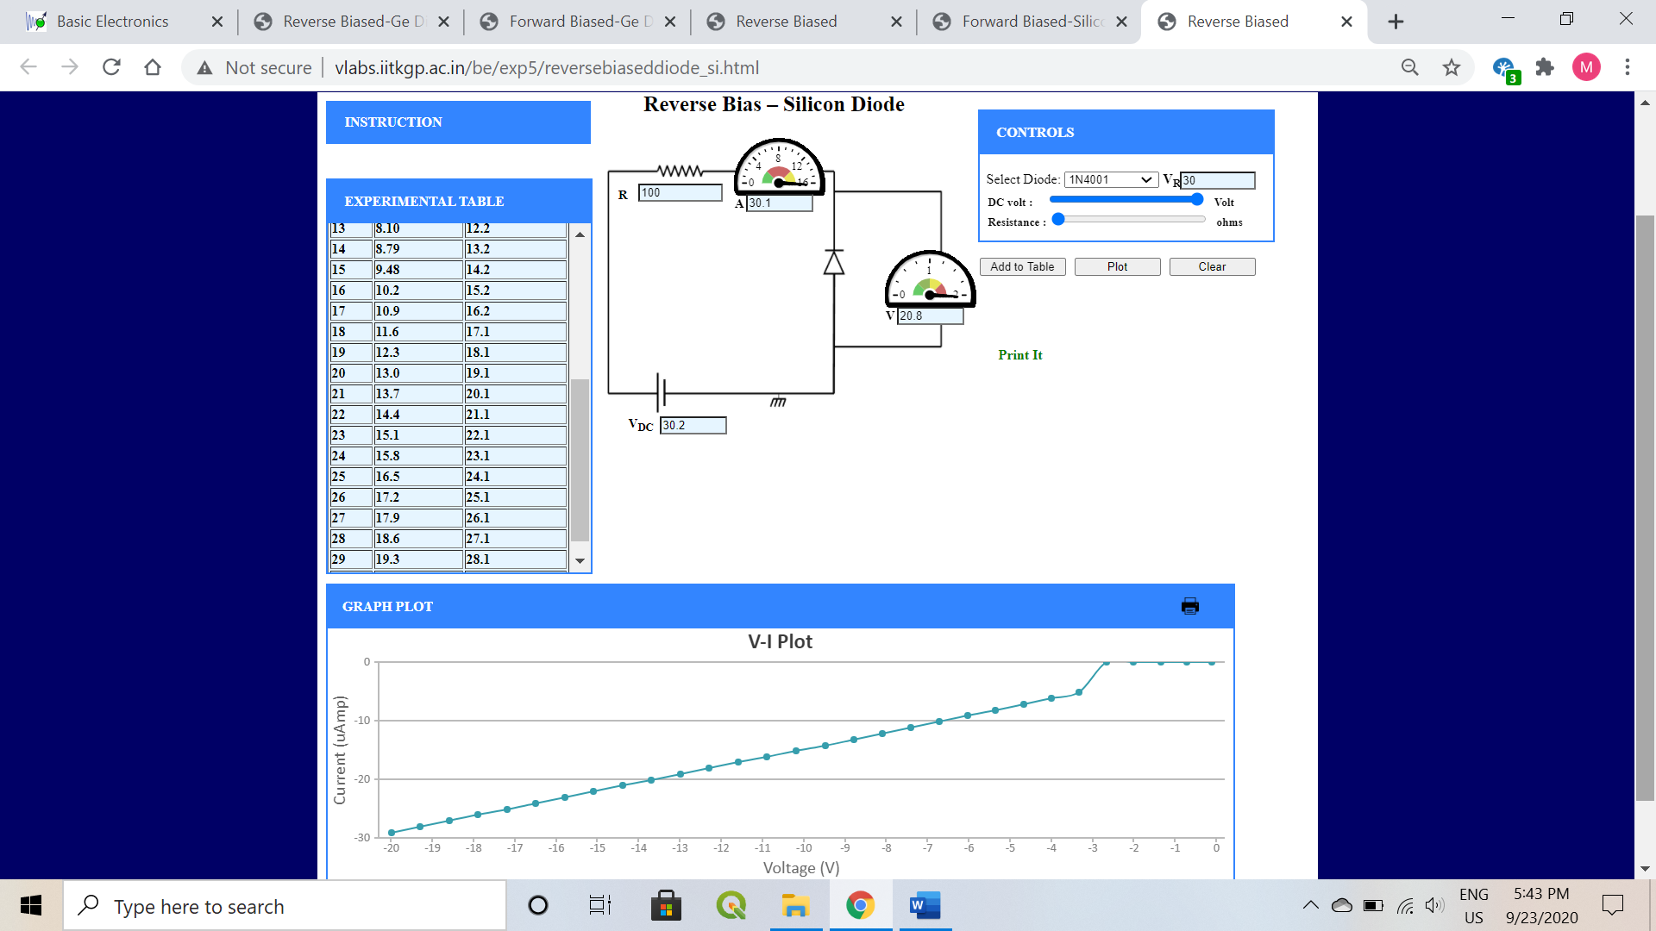

* + Resistance 200 ohms
    - Forward bias

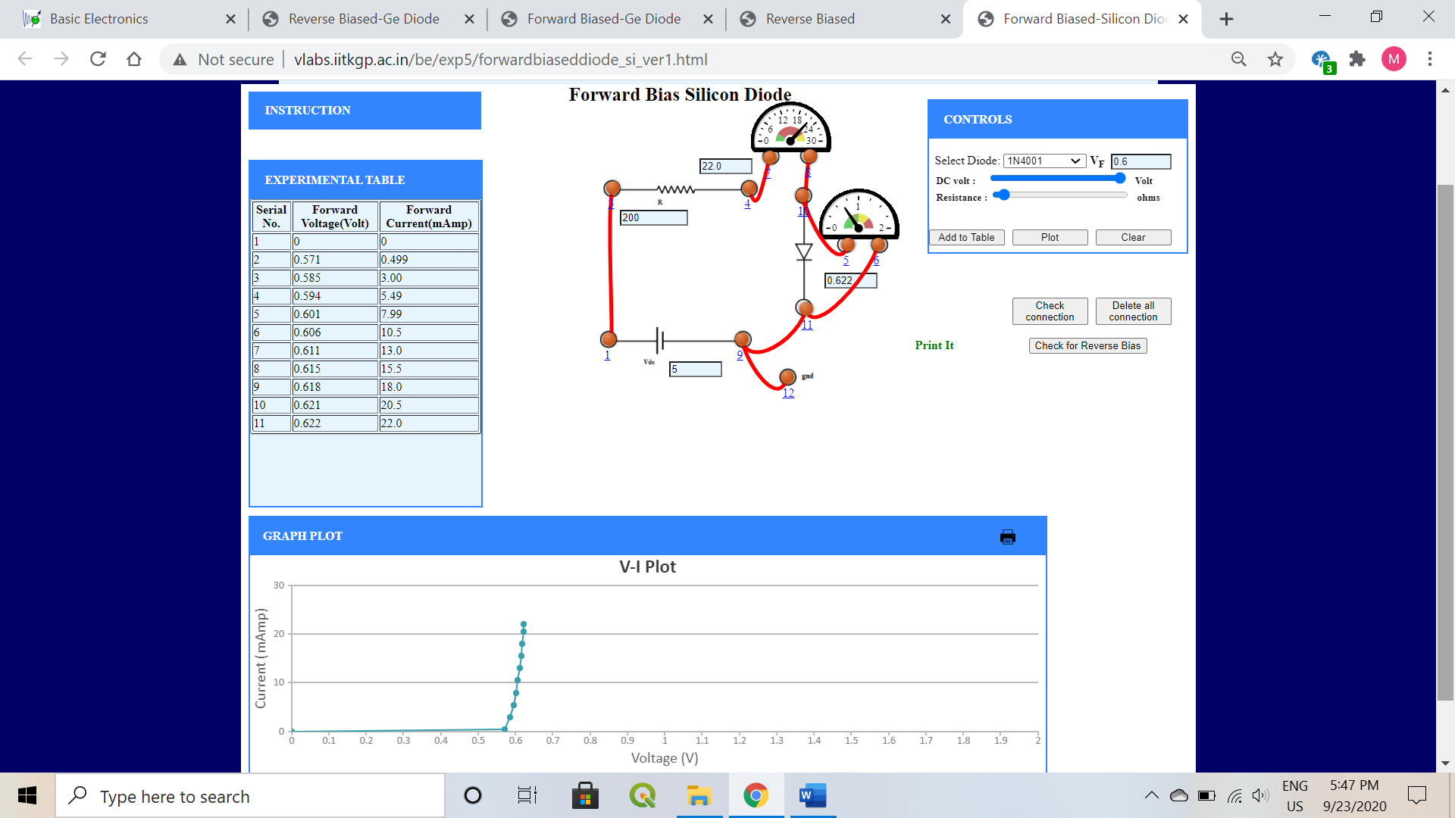

* + - Reverse bias

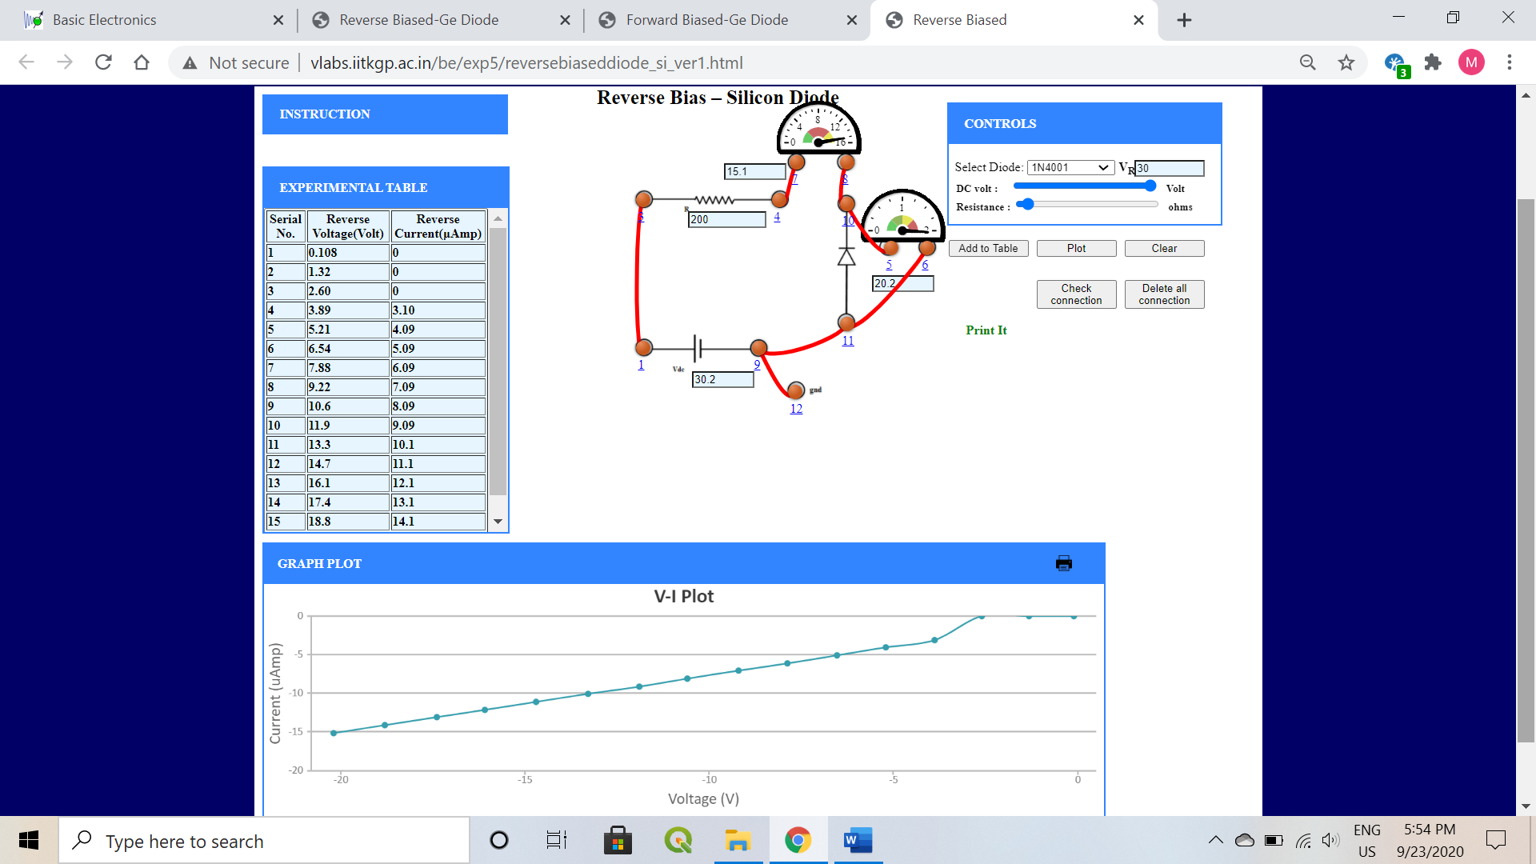

* Silicon Diode (1N4148)
  + Resistance (100 ohms)
    - Forward bias

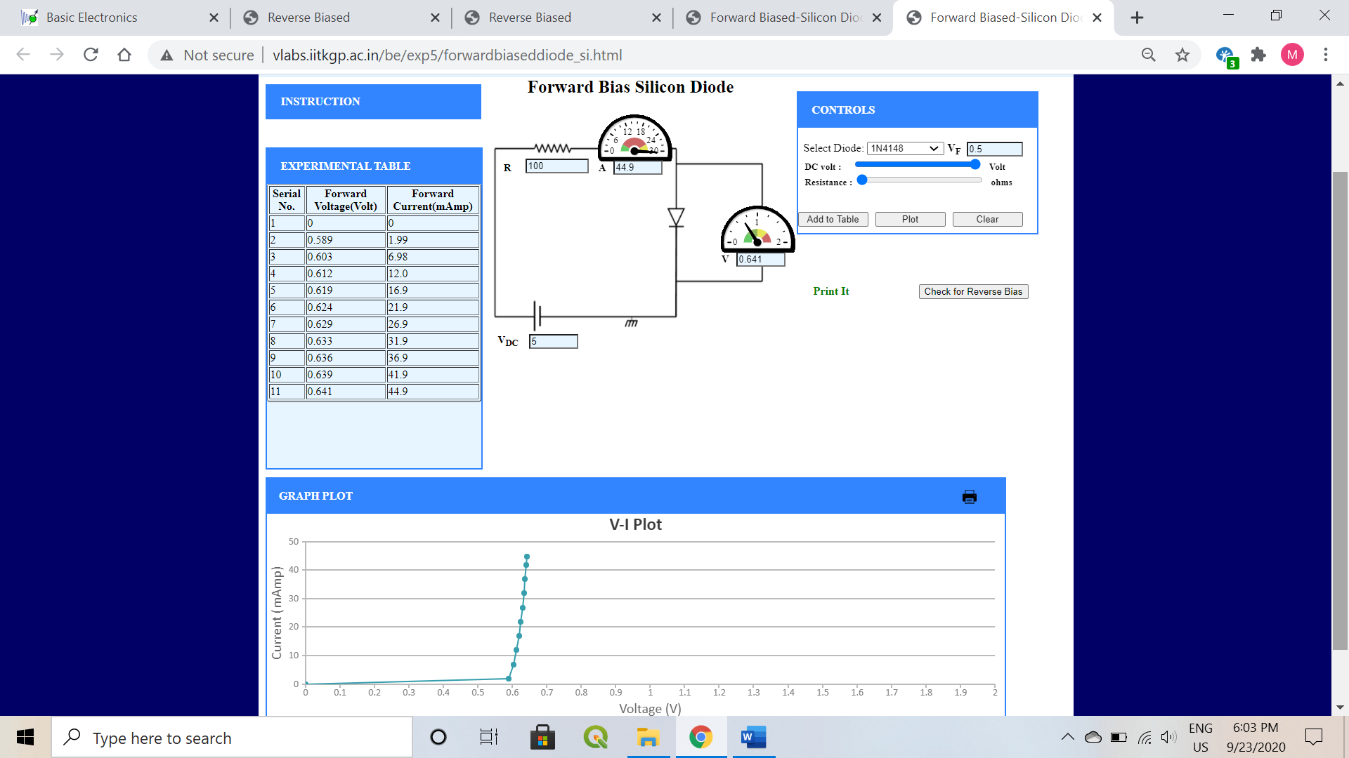

* + - Reverse bias

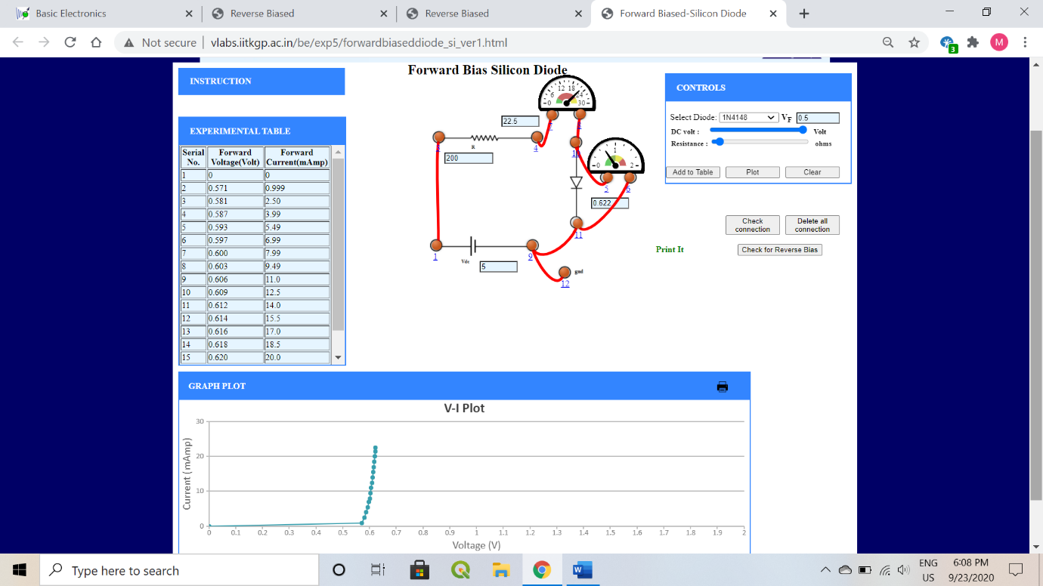

* + Resistance 200 ohms
    - Forward bias

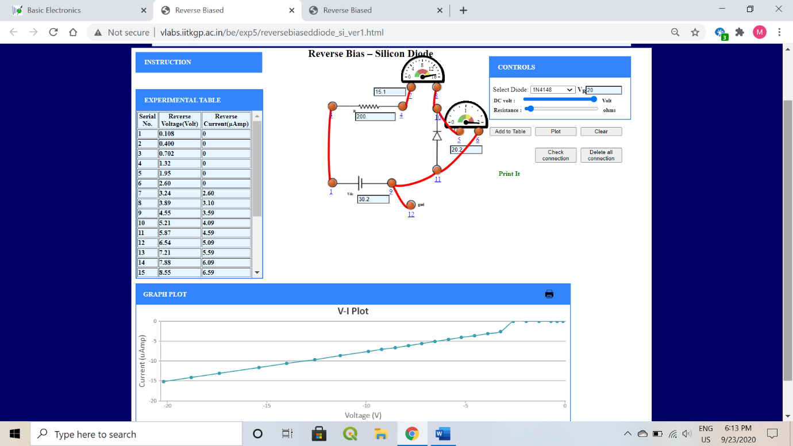

* + - Reverse bias

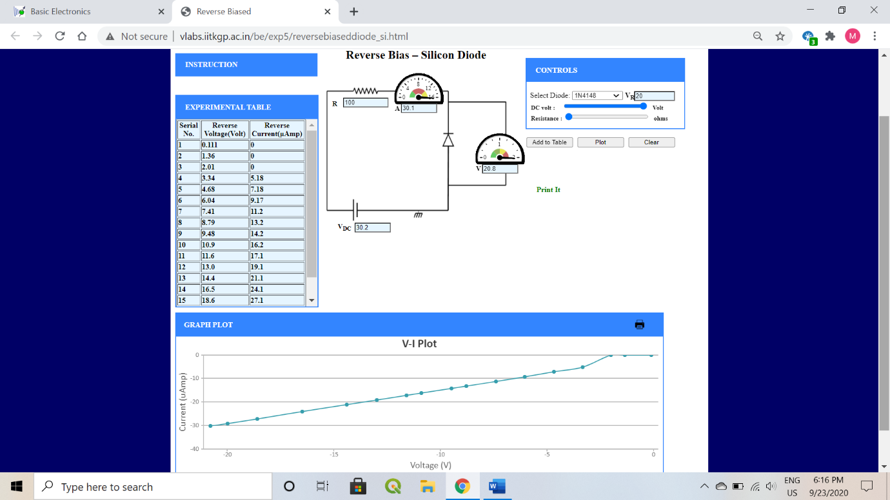

* Germanium diode
  + Resistance 200 ohms
    - Forward bias

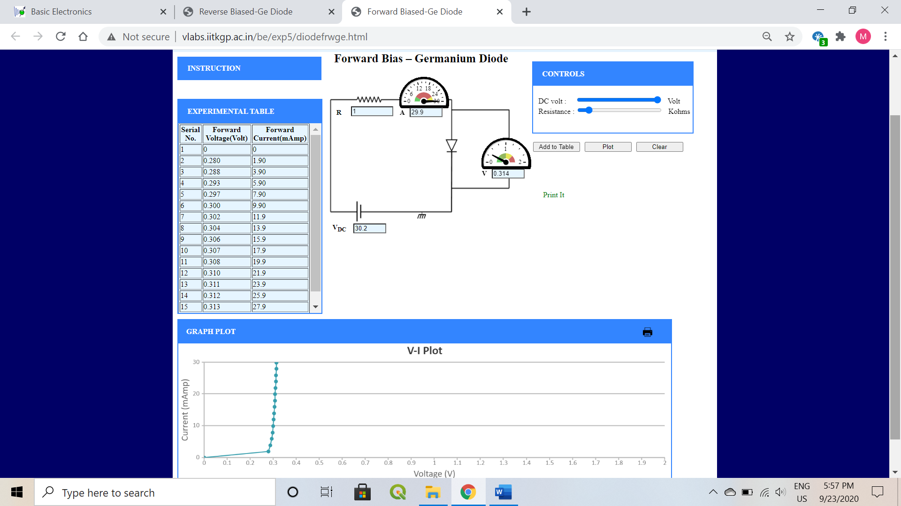

* + - Reverse bias

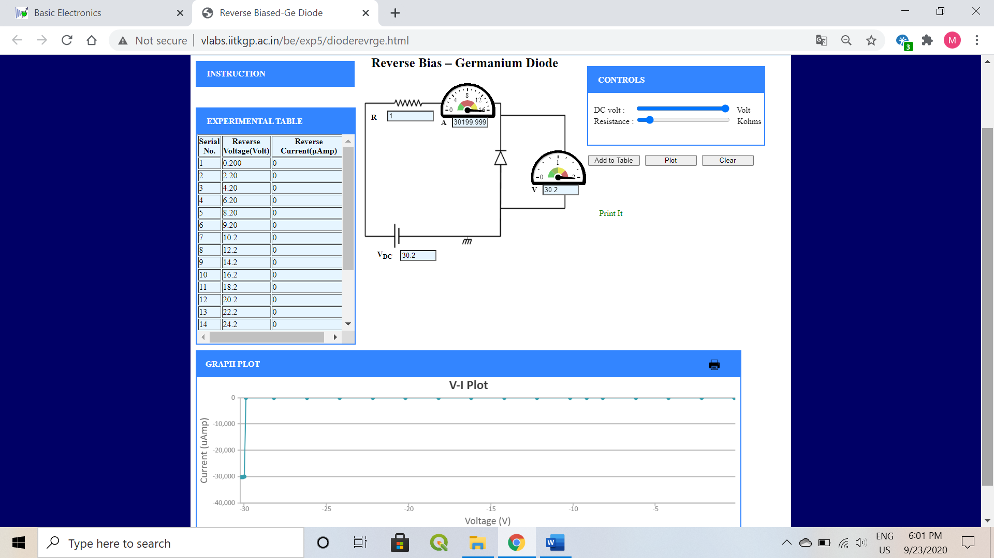

1. **Graph (Image)/Screenshots**

* Silicon Diode (1N4001)
  + Resistance (100 ohms)
    - Forward bias



* + - Reverse bias

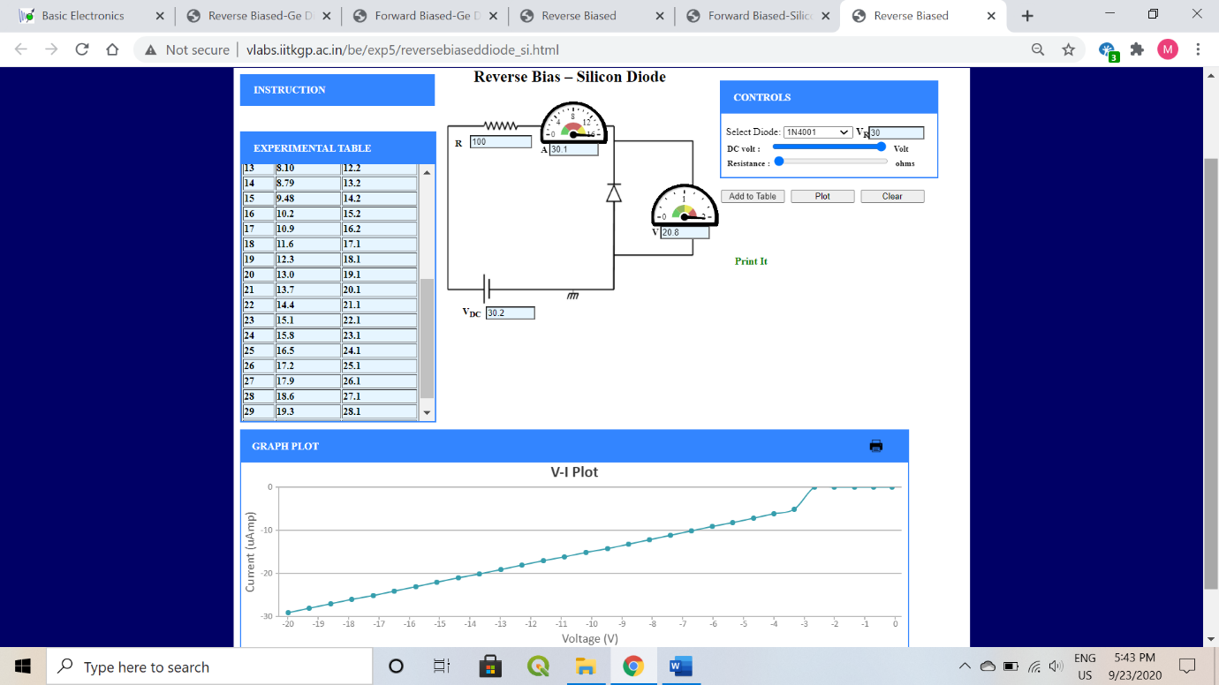

* + Resistance 200 ohms
    - Forward bias

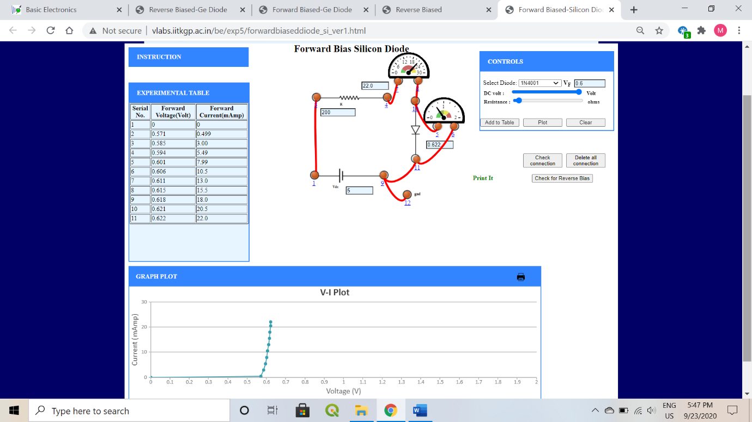

* + - Reverse bias

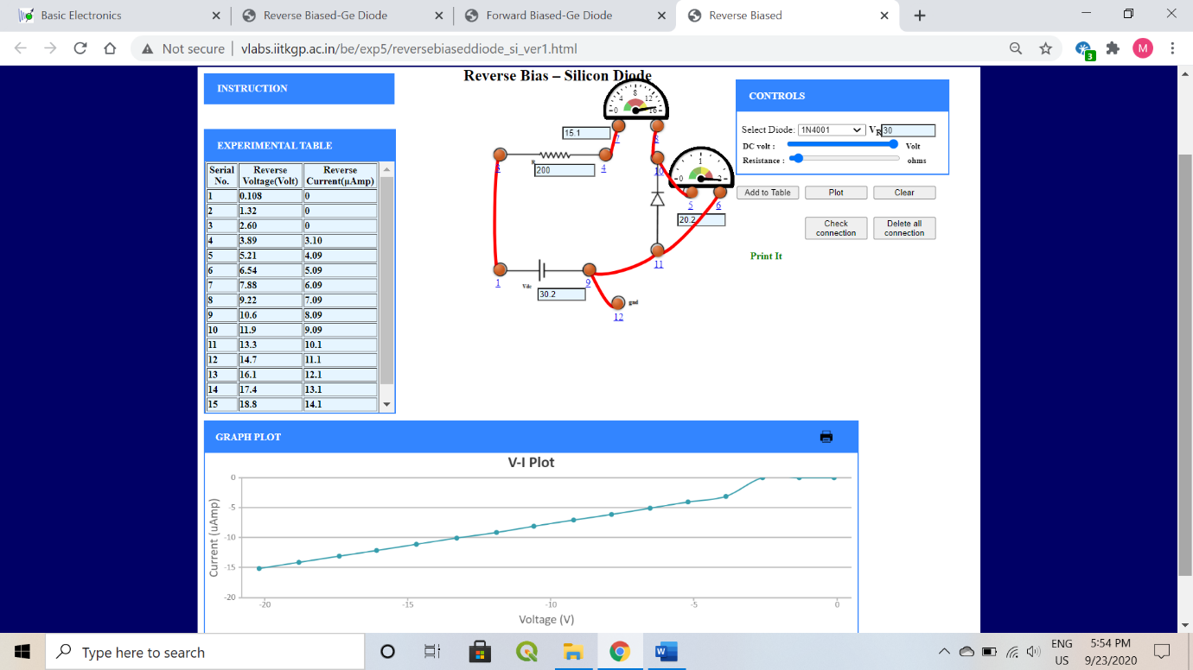

* Silicon Diode (1N4148)
  + Resistance (100 ohms)
    - Forward bias

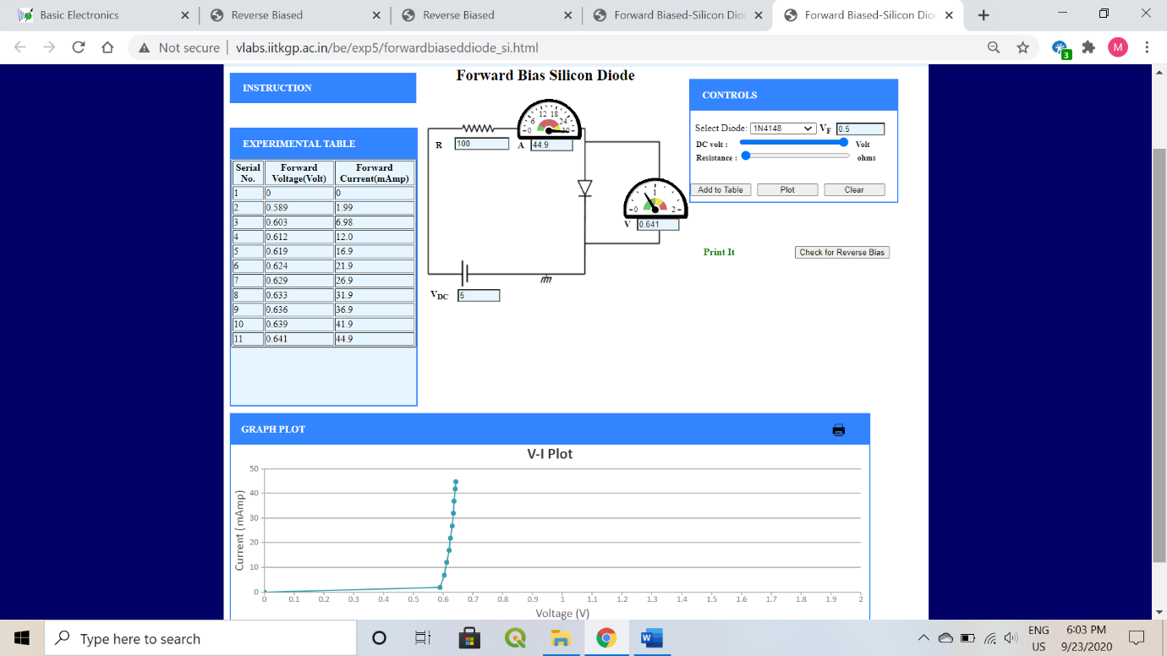

* + - Reverse bias



* + Resistance 200 ohms
    - Forward bias



* + - Reverse bias



* Germanium diode
  + Resistance 200 ohms
    - Forward bias

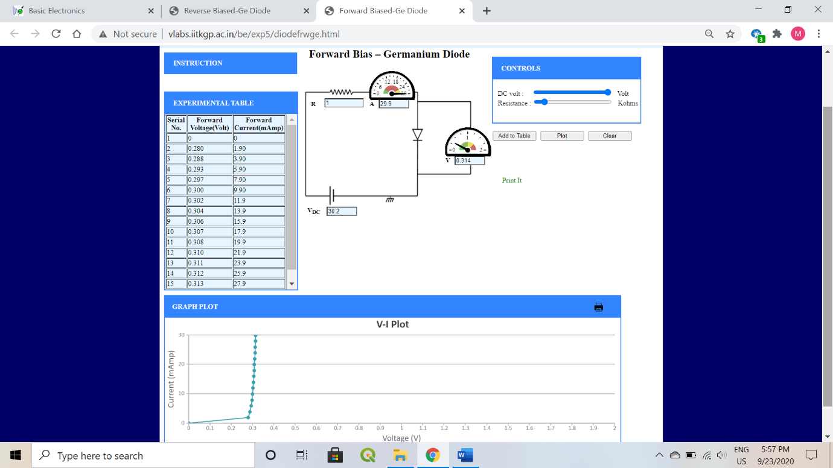

* + - Reverse bias

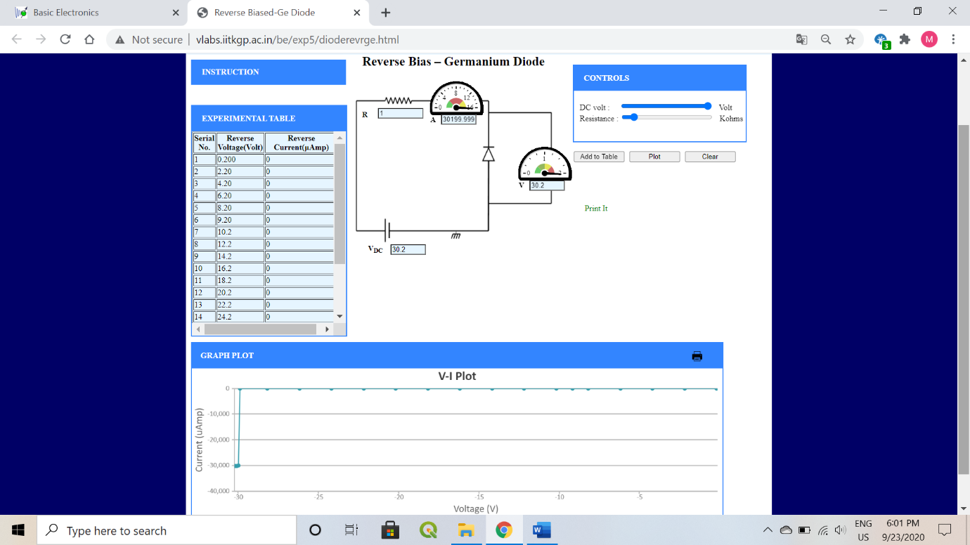

1. **Conclusion**

* We have verified the V-I characteristics for:
  + Silicon diode
    - Resistance 100 ohms
      * Forward bias
      * Reverse bias
    - Resistance 200 ohms
      * Forward bias
      * Reverse bias
  + Germanium diode
    - Resistance 200 ohms
      * Forward bias
      * Reverse bias
* Silicon has a cut-in voltage of 0.6V.
* Germanium has a cut-in voltage of 0.3V.

1. **Discussions**

* We noticed that there was no change in the cutoff voltage by changing the series resistance.
* P-N junction resists current flow in the reverse bias condition and allows the current to flow in the forward bias. Thus, diodes can function as one-way valve.
* In reverse bias the depletion layer of the diode increases and diode acts like an open circuit.
* In forward bias the thickness of depletion layer is reduced and diode acts like a short circuit.

1. **QUIZES:**

